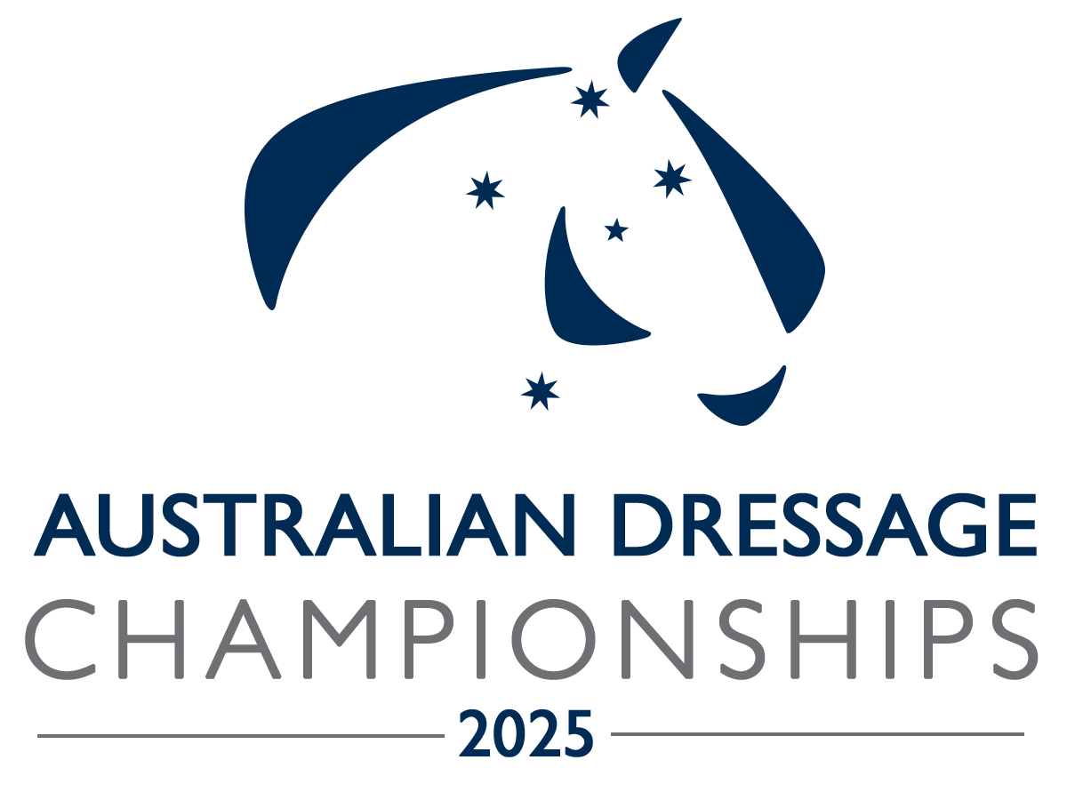

Media Accreditation
  - Introduction

The Organising Committee recognises and values the role the Media plays in providing news and reporting of events.

We welcome Media to the event and invite Media to apply for accreditation to cover the event.

Accreditation is a means of identification and allows access to some restricted areas. It also makes it possible for officials to extend every courtesy to you.

Media representatives will receive Media Passes with free access to the event, (in principle two (2) per publication/type).

Organisers of the Australian Dressage Championships are solely responsible for determining which organisations and individuals will receive accreditation.

- Freelance - This category includes freelance journalists and photographers. For freelance media accreditation, a ‘Letter of Assignment' from a recognised media organisation would be appreciated.
- Photographers/Videographers: The event appoints its own photographers and has special arrangements with them.
  - Photographers/Videographer, who are taking photos for commercial reasons (not for recognised media organisations), may not be issued with accreditation. These photographers can purchase spectator tickets and take photographs from the stands.
  - How to get accredited
All accredited media personnel will be issued with accreditation passes, which must be worn and displayed at all times. Bibs are provided for photographers

We would appreciate applications for Media Accreditation by 10 October 2025 so that we can organise passes for you before the event if necessary.

There is free admission to the event and gate admission tickets are not required.

Please complete the Accreditation Form on page 2 and return to us.
Negotiations are underway and some restrictions may apply for filming/videoing.

Enquiries: Toni Venhaus ph: 0418 686 781
em: ausdressagechamps@gmail.com
Media Accreditation Application – 2025 Australian Dressage Championships

Last Name: | First Name:
Media Organisation

Address:
Tel: Mob:
email:
Type of Media:
TV Radio Magazine
Daily Newspaper Weekly Newspaper Other
Function:
Journalist Camera R/TV Commentator
Photographer Technician Other
Photographers: Do you sell your photographs to competitors or other persons? Yes \ No
Please provide any relevant details:

Note: The event charges a fee of $75 per day for photographers taking photos for commercial reasons unless other arrangements are made with the Organisers (such as providing photos for event use). This includes the fee the Venue (SIEC) imposes fees on Organisers for photographers.

Please provide any relevant details and dates you will be attending:

Are you a Freelance operator? Yes No
Freelance Accreditation is encouraged but a signed letter of commission from a media outlet would be appreciated.
Please provide any relevant details:

Do you have any physical limitations that would require special arrangements? Yes No
If yes, please explain:

Authorisation, Waiver and Risk Warning
If this Accreditation is approved an Accreditation Pass will be issued by the organisers of the Australian Dressage Championships (Dressage NSW on behalf of the Equestrian Australia) for the sole purpose of providing limited access to the designated holder ('the Holder') during this event. This Pass is personal, non-transferable and revocable at any time at Organisers sole discretion. Unauthorized use, alteration or dealing with this Accreditation Pass may result in the temporary or permanent removal of the Accreditation Pass and the possessor's and/or the Holder's ejection from the premises. The Holder assumes all risks incidental to his/her actions, assumes all risks incidental to his/her attending this event, and agrees to indemnify and hold harmless the Organising Committee, Dressage NSW and the Equestrian Federation of Australia, from any and all claims, damages, losses, costs and liabilities including, without limitation, personal injuries and/or property losses, caused by, resulting from or in connection with his/her presence at the event. The Holder may not broadcast, publicise or make commercial use of any visual or audio media of any kind of the Australian Dressage Championships if it breaches any licensing contracts agreed to by the Event Organisers. The Holder irrevocably consents to the use by the Event or any third party authorised by it, of photographs, films, tapes or any other visual or audio media of his/her name, likeness, image or voice in any manner whether authorised or not. The Holder also recognizes that he/she must immediately report the theft, loss or unauthorised use of the Accreditation Pass. Acceptance of an Accreditation Pass constitutes agreement by the Holder of the foregoing conditions.
Signed: _______________________________________________________ Date: __________________
Return form to: email: toni.venhaus@bigpond.com
Enquiries – Toni Venhaus 0418 686 781
Payments for Commercial photography @ $75 per day can be paid by direct deposit to:
Name: Dressage NSW Incorporated
BSB: 032272
Account: 151060
Please note description: 2025 AUSCh photos

